**1. USECASE DIAGRAM**



**2. SEQUENCE DIAGRAM**

**3. CLASS DIAGRAM**

**4. ACTIVITY DIAGRAM**

**5. COLLABORATION DIAGRAM**

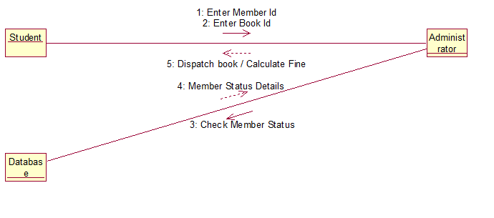

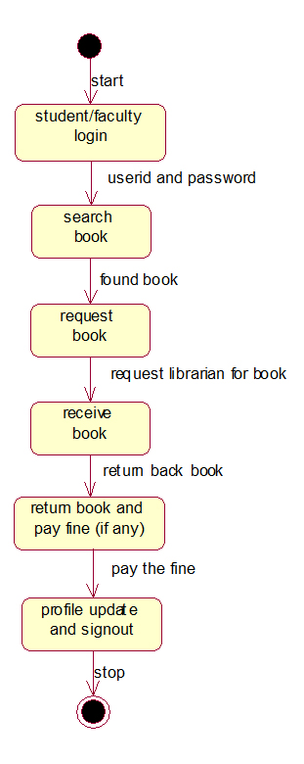**6. STATECHART DIAGRAM**

**7. COMPONENT DIAGRAM**